April 2, 2026 EdCAT Meeting Agenda
1:00-2:30 pm
https://zoom.us/j/94645709998

1. Election of EdCAT Chair for 2026-2027
Chair Nominations – No self-nominations during the meeting.
Chair Elect – No self-nominations during the meeting.
Stacey will send out a webform for nominations.
2. Task Force Reports
Teacher Support Endorsement for Educational Leaders (Karen Bryant)
- Goal – Strengthen educational leaders’ support for teacher well-being and retention
- The committee agreed an additional endorsement would not be the most effective strategy.
- Recommendation - Embed those expectations with the educational leadership rule and standards being revised. This ensures all candidates in prep programs engage with critical content rather than limiting to those who complete the endorsement.
Paraprofessional Marketing Group (Steve Raynie)
- Recommendations
  - Create a web page with program information for USG EPPs
  - Also, made structural recommendations to the website
  - Coordinate state resources
    - Teach in the Peach
    - USG
    - TCSG
    - TCEA
    - GaDOE
  - Create a general inquiry for paraprofessionals from the PSC
  - Identify TCSG schools aligned their ADs with USG core requirements
  - Work with PAGE to host PD days for paraprofessionals
Teacher Shortage (Karen Fisher & Angie Jasper)
- Created a series of subcommittees (Attract, Recruit, Prepare & Develop, and Retain)
- Created a template to guide the work of each subcommittee and charged groups with identifying strategies for each area.
- Below is the Visual Strategy Map for each subcommittee
  - Strategies are scalable
  - Next Steps – Full reports are due May 1, 2026.
  - Ask EdCAT to:
    - Finalize Statewide Strategy Framework
    - Select Priority Strategies
    - Define Roles & Ownership
    - Provide Implementation Timeline
    - Identify Funding Streams
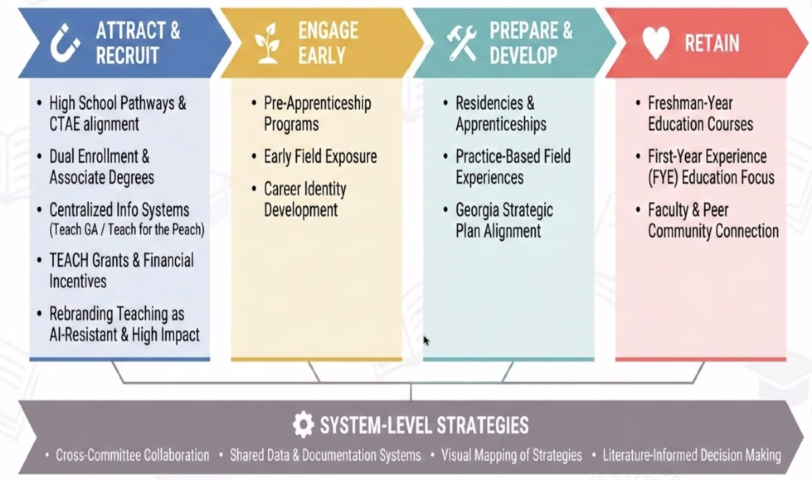

High School Pathway (Kelly McFadden)
- The goal was to examine whether students completing both pathways in high school could be awarded expanded credit (e.g., 9 credit hours). The general consensus was that there is insufficient alignment to justify awarding 9 credits. However, there may be an opportunity to revisit this if pathway standards are revised to increase overlap.
Alt and Out-of-State Providers (David Biek & Sheri Hardee)
- Charge: Examine the impact of alternative approaches to teacher education and engage with the PSC on related policy considerations.
- Discuss challenges and key pain points associated with out-of-state providers.
- Initial conversations with PSC included an economic perspective, particularly comparing outcomes for students prepared by out-of-state providers versus those prepared in Georgia. Earlier data suggested a 5-year retention rate of 63% for out-of-state providers, compared to approximately 75% for Georgia-prepared educators.
- However, updated data provided by PSC for out-of-state providers indicates higher retention rates: Year 3 – 90%; Year 5 – 87%
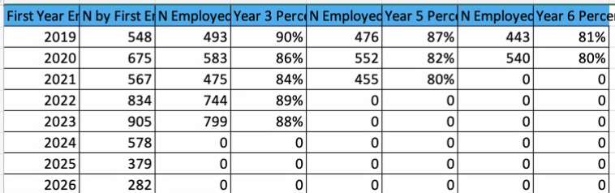

- Minimal differences were found between out-of-state providers and those within Georgia, weakening the economic argument for prioritizing USG institutions.
- Although the committee identified a set of key questions, it became evident that the GaPSC does not currently have the data needed to fully address them (e.g., student success outcomes).
- Additional data sources, such as the Georgia Department of Education (GaDOE), would be necessary to support further analysis. Next Steps –
  - Refine committee questions
  - Identify data sources to answer questions to make our argument to support Ga providers
  - Recommendation will be exploring what competency-based teacher preparation could look like within the USG.

Supporting Candidate Well-Being (Alyssa Barnes)
- Identify patterns and trends committee members are observing among candidates.
- Determine the key competencies (strategies and skills) candidates should develop to support their well-being.
- Develop a survey to capture current practices across institutions.
- Compile a repository of effective practices related to candidate well-being (e.g., Georgia Southern’s resilience training for juniors and seniors, as well as professional development for faculty).Examining Ga Medical College and how they are doing their student supports.
  - Looking for partnerships within their own regions to accumulate a resource list based on geography to link candidates with support resources.
- Recommendation – Extend this work into next year because it has taken a great deal of time.
USG/GaPSC Steering Committee (Carla Tanguay)
- Discuss initiatives, policy changes, Keep Deans informed and engaged in shared decision making.
- Mother Rule Advisory Committee created a survey – results are in
- Discussion around MOUs – Are they necessary, etc.. More coming.
- Registered Tacher Apprenticeship Programs – 33 apprentices; 132 apprentices seeking a bachelor’s degree and still employed as paras. 50 seeking certifications in dual field of ELEM and SPED. More funding may be forthcoming.
- TCSG 2+2 Articulations – not a seamless pathway for teacher certification
- GaPSC had 21 data conversations since August; 26 program reviews for 2027
- Challenges with new GACE Assessment results – getting the results from the portal.
- Updates from the Georgia Council on Literacy – GaPSC monitoring EPP progress with SOR implementation.
- Legislative Impacts – HB 310; HB 1030; HB 1107; HB 1193; HB 1302
- Support for EPPs in writing up Standard 6 – Literacy Suite
- Education Collaborative Programs – Ex: BSED in SPED; BSED in Secondary Education
3. USG Updates from Laura Lynch
- 49 views on the paraprofessional USG page.

- Reduced credit bachelor’s degrees – 90 credit hour bachelor’s degree – 3 years. Typically focused on high demand, technical careers. USG has been in discussions with Provosts. SACSCOC developed updated guidance.
- PASSED BY GEORGIA HOUSE AND SENATE:
HB1193 Georgia Early Literacy Act https://legiscan.com/GA/bill/HB1193/2025
  - May impact teacher shortages in Georgia
HB 1030 Math Matters Act: https://legiscan.com/GA/bill/HB1030/2025
HB 1107 Excellent Teacher Preparation Act: https://legiscan.com/GA/bill/HB1107/2025
HB 1302 Education and Workforce Strategy Act: https://legiscan.com/GA/bill/HB1302/2025
- Renames GOSA to Governor’s Office of Education and Workforce Strategy
TCSG – official agencies for apprenticeships
HOUSE PASSED/SENATE TABLED:
HB 310 Student Teacher Promotion Act: https://legiscan.com/GA/bill/HB310/2025
- Small stipends for student teachers would be administered through the Georgia Student Finance Commission and allocated to institutions for distribution.
In COMMITTEE:
HB 974 General Appropriations for July 1, 2026 – June 30, 2027: https://legiscan.com/GA/bill/HB974/2025
- Proposed a reduction to the university system budget tied to online learning, based on the assumption that online courses are less costly to deliver. Legislators are suggesting a revised funding model in which institutions would need to generate approximately 10% more online credit hours to receive the same level of funding (e.g., 3.3 credit hours to equal the funding of 3 traditional credits). This represents an estimated $123 million reduction and is expected to affect institutions unevenly, depending on the extent of their online course offerings.
4. Summer meeting? If so, when?
Preference for Summer Meeting – June, July, or Early August
Survey forthcoming.

